**Bootstrap navbar component** is useful for creating responsive navigation header for a website. By responsive, we mean that the navbar is collapsed on small screen size devices like mobile phones. When the toggle button is clicked the navbar expands. However, on large screen devices like laptops and desktops, where we have enough room to display the entire navbar, it appears normal.

**Creating responsive navbar :** The navbar appears normal on a large screen size devices like laptops, desktops etc.   
bootstrap navbar examples  
  
The navbar appears collapsed on a small screen size devices like mobile phones, portrait tablets etc. The navbar expands when the toggle button is clicked.   
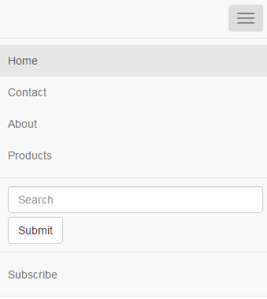

<nav class="navbar navbar-default">

    <div class="navbar-header">

        <button type="button" class="navbar-toggle" data-toggle="collapse"

                data-target=".navbar-collapse">

            <span class="icon-bar"></span>

            <span class="icon-bar"></span>

            <span class="icon-bar"></span>

        </button>

    </div>

    <div class="navbar-collapse collapse">

        <ul class="nav navbar-nav">

            <li class="active"><a href="#">Home</a></li>

            <li><a href="#">Contact</a></li>

            <li><a href="#">About</a></li>

            <li><a href="#">Products</a></li>

        </ul>

        <form class="navbar-form navbar-left" role="search">

            <div class="form-group">

                <input type="text" class="form-control" placeholder="Search" />

            </div>

            <button type="submit" class="btn btn-default">Submit</button>

        </form>

        <ul class="nav navbar-nav navbar-right">

            <li><a href="#">Subscribe</a></li>

        </ul>

    </div>

</nav>

**Useful nvabar classes**

| **Class** | **Purpose** |
| --- | --- |
| navbar-inverse | Modifies the look of the navbar by creating an inverted variation of it |
| navbar-fixed-top | Creates navbar that is fixed on the top of the page |
| navbar-fixed-bottom | Creates navbar that is fixed at the bottom of the page |

**Please note :**  
1. To center and pad navbar content use container or container-fluid classes.   
2. The fixed navbar may cause some of the page content on the top or bottom invisible. To push the content up or down add padding to the top or bottom of the <body> element.